**FORM 410**

(*See* rule 40(2)(a))

*Application for issue of order under sub clause (ii) of clause (b) of sub section (1) of the section 31 of the Maharashtra Value Added Tax Act, 2002 for no deduction of tax*

To

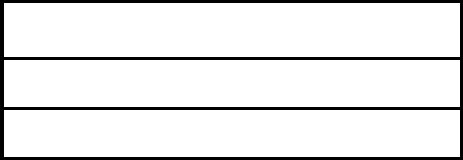

1. Name and address of the applicant
2. Tax Identification Number if any under the M.V.A.T Act, 2002



***I / We, am /are undertaking the activity of execution of certain contracts and do hereby apply for the issue of order for no deduction of tax,***

***as per the provision of sub clause (ii) of clause (b) of sub-section (1)***

***section 31 of the said Act.***

The necessary details are as under: -



* Name and full address of the Employer who has awarded the contract.



* TIN of the Employer under M.V.A.T. Act, 2002 if any,

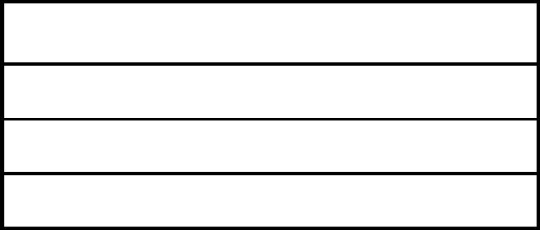

* Address of the place where the Contract is executed



* The description of the contract to be executed (copy of the contract to be filed with the application)



* Date of commencement of the work



6 Expected date of completion of the



work



* Total value of the contract under reference

I/we request you to determine whether the contract is a works contract for the purposes of the said Act and accordingly whether the employer is justified in deducting tax at source while making payment to me/us.

I solemnly declare that the above information is correct to the best of my knowledge and behalf.

Place ü



Signature



Date



Status



Encl.:Copy of Contract